**Leader Overview**



**Volume Overview**

**Get Going**

*The gift of the Holy Spirit was sent so that we might have power—power to go and make disciples. Some go to the farthest corners of the globe. Some only cross the street in front of their house. Still, God’s people always go. They go to work, school, grocery stores, kids’ soccer games, and family reunions. And wherever they go, they take their witness of Jesus with them. True believers live going and carrying out His mission.*

**Session Overview**

**Embrace Your Role**

*In this* ***Live*** *session, preschoolers will discover the truth that God has a special purpose for their life. God created each of us to be unique. Like John the Baptist, we can point others to Jesus and fulfill our most rewarding purpose.*

**Bible Lesson**

John the Baptist Points to Jesus

[John 1:19–34](https://ref.ly/logosref/Bible.Jn1.19-34)

**Faith Fact**

I have a purpose.

**Faith Verse**

[John 20:21](https://ref.ly/logosref/Bible.Jn20.21) (NLT)

[Jesus] said, “Peace be with you. As the Father has sent me, so I am sending you”

**Preparing for the Session**

**Leader Preparation Time: 20–25 Minutes**

|  |
| --- |
| ***You Will Need***  ***Preservice Activities***  *•* ***Bible Story Warm-Up Page****, one per group*  *• Optional: Sports balls*  *• Animal crackers*  *• Toys*  ***Large Group***  *• Bible*  *• Worship songs (Song suggestions: “Do What You Wanna Do” Lyric Video by Elevation Church Kids; “I Know I Belong” Lyric Video by Saddleback Kids*  *• For groups not using a phone or tablet only, add:*  *• Projector or TV*  *• Laptop*  *•* ***Faith Fact Sound*** *video (bell ringing)*  *•* ***Faith Fact Slide***  ***• Faith Verse Slide*** *or* ***Video***  *•* ***Bible Lesson Video A***  *•* ***Bible Lesson Video B***  ***Small Group***  *• Handheld mirror*  *•* ***Small Group Activity Page****, one per kid*  *• Washable markers*  *• Wipes*  *• Small paper or plastic plates, one per kid*  *•* ***Small Group Hands-On Learning Page****, one per kid*  *• Scissors*  *• Card stock*  *• Quart-size zipper plastic bags, one per kid*  To access session content and videos from a computer, visit: [**BibleEngagementProject.com/downloads**](https://bibleengagementproject.com/downloads) |
| ***Getting Ready***  ***Preservice Activities***  *• Set out toys and snacks.*  *• Print the* ***Bible Story Warm-Up Page****, one per group.*  ***Large Group***  *• Download videos and slides if needed.*  *• Select worship song(s) and have them ready to play.*  ***Small Group***  *• Print copies of the* ***Small Group Activity Page****, one per kid*  *• Print the* ***Small Group Hands-On Learning Page*** *on card stock, one per kid. (Two options are available: color and black/white.)*  *• Optional: Cut apart some or all of the pictures depending on the skills of your group. Put the pictures in a zipper bag for each kid.*  ***First time leading* Live *for Preschool? Check out the*** [**Facilitator Guide**](https://0b769b0ed3569ef9d18b-f88d8272f61086866d50d048b43ef630.ssl.cf2.rackcdn.com/sites/biblengagementproject/Listen_Facilitator_Guide.pdf)**.** |

**Preservice Activities**

*See what’s needed at the beginning of the session.*

**Bible Story Warm-Up**

• *Hold up the* ***Bible Story Warm-Up Page.***

What does this picture show?

Do you play any sports?

What sports do you like to play?

Can you find the ball for the sports that you like to play?

• *Discuss each of the balls and the sports (American football, soccer, volleyball, basketball, baseball, tennis, etc.)*.

Not only are these balls used for different sports, but they also all look different. How are they different? *(Allow responses.)* One of these balls even has a unique shape. Can you point to it? *(Group response)*

This ball is used for football in the United States. It’s not round like other balls, but more like an oval with points at the ends. You can throw it, kick it, and run with it like other balls. Can you play soccer with it? *(Group response)* Can you play baseball with it? *(Group response)* No, this ball could be thrown between friends, but it would be really hard to play soccer or baseball with it. A football is unique. It was made specifically to play one sport: football. It has a special purpose.

God made you special and unique. He created you for a job that only you can do best. Today, we’ll learn all about this. I can’t wait to learn more with you.

**Snack**

**Animal Crackers**

We have an awesome snack today. Before I hand it out, I have a question for you. When I say, “Go,” I want you to tell me what your favorite animal is. Ready? Go! *(Group response)* Whoa! That was a lot of different animals. My favorite animal is a *(insert favorite animal).* I love them because *(describe a unique trait about the animal).*

• *Hand out animal crackers while describing your favorite animal.*

Today for snack, we have animal crackers. I like to take my time and look at each animal. They all look different. Before you eat your snack, I want you to pick three different animal crackers. Find something about them that helps them be the special animal they are. Maybe you’ll pick the elephant that has a long trunk that helps it spray water to keep cool. Maybe it’s a giraffe with a long neck to reach up high and get leaves to eat. When you figure out the special thing about the animals, I want you to make the noise the animal makes.

• *Let kids discover the special traits of each animal and then make their animal noises before instructing them to eat their snack.*

Wow! You definitely know a lot about animals. It was really cool to hear all the special things you noticed about them. It’s pretty amazing that God created each one of them with something special that helps them do something that only they can do. In our Bible story today, we’ll learn how God has special jobs for us, too.

**Free Play**

*Any extra time can be spent playing with toys.*

**Transition**

*A few minutes before service begins have kids make their way to the large group area and sit in their designated areas.*

**Large Group**

**25 Minutes**

*See what’s needed at the beginning of the session.*

**Introduction**

Hi, friends! It’s so good to be here with you today! My name is _________. Look at the friend next to you and say your name. Good job! We’ll explore a really interesting Bible story today. *(Hold up the Bible.)* If you’re ready to explore God’s Word with me, give me a big thumbs up! *(Group response)*

Today, we’ll learn about a man named John the Baptist. He wore some really interesting clothes and ate some really interesting things. He ate something that you and I don’t eat. Watch closely during our Bible story and see if you can figure out what it is. He didn’t live like many of the people around him, but he said it was for an important purpose.

**Faith Fact**

John the Baptist made his purpose in life to point people to Jesus. That’s our Faith Fact today! **I have a purpose.**

• *Show the* ***Faith Fact Slide.***

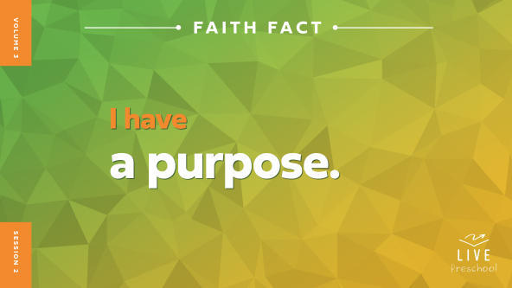

Let’s say it together and point to ourselves when we say it. **I have a purpose.** Great! Now, let’s say it super loud! **I have a purpose.**

**Bible Time**

One of my favorite things to do is explore stories and truths from the Bible. We have someone who often helps us with that. Can you remember her name? *(Group response)* Yes, Lizzy is her name. Let’s check in with her.

• *Play* ***Bible Lesson Video A.***

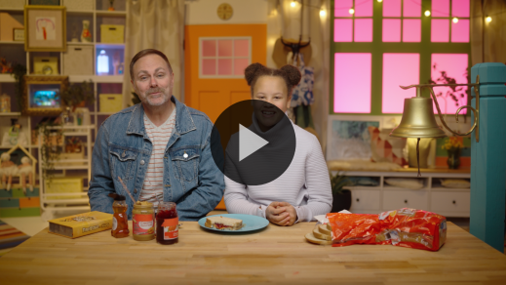

I’m glad Grandpa gave us a little time to think. Let’s worship and then come back to see what happened in the story.

**Worship**

When I explore Bible stories, I’m always reminded of how amazing and good God is. That makes me want to praise Him. Can you think about how much God loves you right now? He loves us a lot! Let’s give Him our praise and worship for a few minutes.

**Praise**

Who wants to thank Jesus for His great big love? Spread your arms out wide. *(Group response)*

Are you glad Jesus came to the earth to be our Savior? Clap your hands three times. *(Group response)*

Who wants to be more like Jesus? Wave your hands up high. *(Group response)*

**Sing**

We can worship God by singing. Let’s remember that He hears every word we sing and every prayer we pray.

• *Lead the kids in singing one or two songs. See song suggestions at the beginning of the session.*

**Prayer**

Those songs are so true. God loves to be close to you. Let’s bow our heads and talk to God.

|  |
| --- |
| *Dear God, thank You for how amazing You are. You love all of us so much, and we want to grow closer to You. Help us to become more like You each day. We love You. Amen.* |

**Bible Time cont’d**

• *Start* ***Bible Lesson Video B*** *and pause on the image of the two choices.*

It’s time for Grandpa and Lizzy to come back! Okay, let’s put on our thinking caps *(demonstrate)*. What do you think happened next? Did John the Baptist say he was the Messiah? *(Point to “mirror” graphic.)* Or did he point to Jesus as the Messiah? *(Point to “cross” graphic.)*

If you think John the Baptist said he was the Messiah, point to yourself. If you think John the Baptist pointed to Jesus as the Messiah, point up to the sky. Ready? Choose your answer.

• *Pause while kids respond.*

Let’s find out if you’re right! Let’s check back in with Lizzy and Grandpa.

• *Play* ***Bible Lesson Video B.***

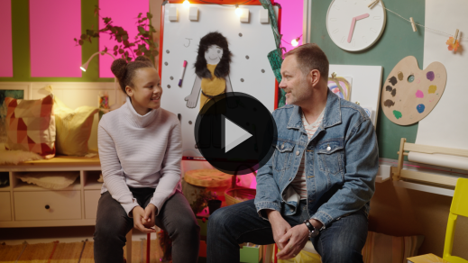

What a great story Lizzy and Grandpa shared with us! I feel like God has a purpose for me to point some amazing kids to Him. Do you have any idea which kids I might be talking about? *(Group response)* Of course, it’s you!

**Response Time**

*Play a worship song quietly.*

My prayer is that I can show you what a great purpose God has for you. That starts today. Let’s respond to what we’ve heard today. Let’s pray together.

• *Have the kids repeat phrases of the prayer after you.*

|  |
| --- |
| *Dear Jesus, thank You for coming to the earth as a man. You love us so much that You went to the Cross as our Messiah. We want to point others to You just like John the Baptist did. Please help us do that in a powerful way this week. Amen.* |

**Faith Verse**

God loves it when we talk to Him. He also loves it when we learn Bible verses from His Word. Let’s say our Faith Verse and do the actions together.

[John 20:21](https://ref.ly/logosref/Bible.Jn20.21) (NLT)

[Jesus] said, ”Peace be with you. As the Father has sent me, so I am sending you.”

• *Show the* ***Faith Verse Video.***

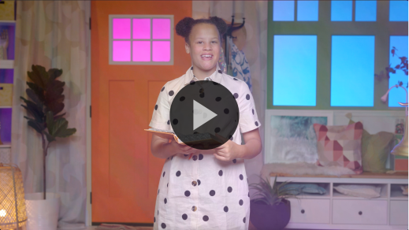

**John** *(hands at waist, spread apart, palms up and out)*

**20:** *(hands together like a clap)*

**21** *(hands opened to “book”)*

**Jesus said**, *(sign language for Jesus—middle finger touches center of opposite hand palm on both hands)*

**“Peace be with you.** *(wrap arms around each other like giving yourself a hug)*

**As the Father has sent me**, *(point up both index fingers for Father)*

**so I am sending you.”** *(sign language for Jesus—middle finger touches center of opposite hand palm on both hands, and then both index fingers point away from body)*

Wow, great job, friends! Keep practicing our Faith Verse at home, and we’ll say it again when we’re together!

**Closing**

Did you learn more about Jesus and His great love for you today? *(Group response)* We’ve worshipped Him by singing and praying. We practiced our Faith Verse. Does anyone remember what book of the Bible our Faith Verse is in? *(Group response)* Yes, it’s the Book of John. We learned about John the Baptist, a man who led an interesting life and said yes to his great purpose of pointing people to Jesus.

• *Play the* ***Faith Fact Sound*** *video (bell ringing).*

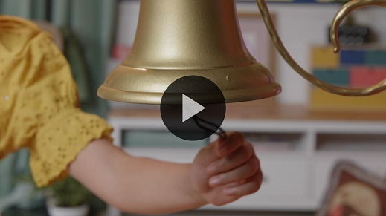

That’s our Faith Fact sound! We get to say our Faith Fact one more time: **I have a purpose**.

• *Show the* ***Faith Fact Slide.***



Let’s whisper it together. Ready? **I have a purpose**. Now, let’s use our biggest voices because God has a big purpose for each one of you. **I have a purpose**.

**Dismissal to Small Groups**

Great job! It’s time for you to have so much fun with your friends and leaders in your small groups.

• *Dismiss the kids by groups.*

|  |
| --- |
| ***Leader Tip:*** *This can be done by assigning color teams or by age groups. Note that some young preschoolers may not know their age. Using a colored sticker, jersey, or wristband will help separate the kids and help identify their small groups.* |

**Small Group**

**25 Minutes**

*See supplies and prep instructions at beginning of session or in each activity below.*

|  |
| --- |
| ***Leader Tip:*** *Small groups can alternate to each circle, or all groups can do each activity at the same time. If you choose to alternate, you will need at least one leader per circle.* |

**Circle 1**

**Group Connection**

**Mirror Me**

|  |
| --- |
| ***You Will Need***  *• Handheld mirror*  *No prep needed for this activity.* |

In our Bible story today, we learned about a man named John the Baptist. John lived in the wilderness and ate some unusual food. What did he eat? *(Allow responses.)* He loved honey, and sometimes he ate bugs. *(Make gross face.)* While he was living outside, I’m sure his hair got a little crazy. It’s probably because he didn’t have one of these. *(Hold up mirror.)*

John had a very important job to do. His purpose was to let other people know that Jesus was coming. He told people that Jesus had a very special job. Later, we learned that it was to save us all. That reminds me of our Faith Fact. Can you say it with me? **I have a purpose.**

John may not have had a mirror like this one, but imagine if he did. He would have seen how special God had made him. We’ll take turns passing this mirror around the group. When it’s in front of you, I want you to look at yourself, smile really big, and tell us something special about yourself. Then, say the Faith Fact: **I have a purpose.**

• *Pass the mirror around the circle.*

• *Be ready to help the kids say something special about themselves.*

You have been created so special by God! Look at each other. Does anyone look the same? *(Group response)* Not one of you is the same as the person next to you. That means God wants to use each one of you for a special purpose like John the Baptist.

**Circle 2**

**Activity Page Time**

**Thumbprint Art**

|  |
| --- |
| ***You Will Need***  *•* ***Small Group Activity Page****, one per kid*  *• Washable markers*  *• Wipes*  ***Getting Ready***  *• Print copies of the* ***Small Group Activity Page****, one per kid.* |

Did you know that God made you unique? He made your eyes the way they are and your hair the color it is. Even your fingerprints are unlike anyone else’s. I think this is a great reminder that God made each one of us special so that we can do what He’s created us to do. He made you and me on purpose and with a specific purpose. That makes our Faith Fact so much easier to remember. Why don’t we say it together? **I have a purpose.**

That’s true of everything God created. He is careful to create things with special purposes. You’ll use your thumbprint to make some things God created with a purpose. As you add your thumbprints to make the pictures, let’s talk about the purpose God has for each thing on our page.

• *Hand out a copy of the* ***Small Group Activity Page*** *to each kid.*

• *Help kids color their thumb with the washable marker and press it onto the page.*

• *Talk about the purpose of everything on the page.*

• *During the activity, interrupt and practice the Faith Fact:* **I have a purpose.**

• *Play the* ***Faith Fact Sound*** *video. Review the Faith Fact even if you can’t play the sound.*



Look at our pictures! It’s amazing how many things God created with purpose and how unique they all are. I love this beautiful reminder that God wants to use each of us in a different and special way. He wants to use you for a purpose that only you can do. Why don’t we say our Faith Fact together to help us remember that we have a purpose? **I have a purpose.**

We all share one purpose, and that’s to tell other people about Jesus and His love. Because God made you unique, how you share God’s love with other people will be special just like you are.

**Circle 3**

**Feet-to-Floor Game Time**

**Locust and Honey Tag**

|  |
| --- |
| ***You Will Need***  *• Small paper or plastic plates, one per kid*  *No prep needed for this activity.* |

If you’re ready to play a game, say, “Uh-huh!” *(Group response)* Perfect! I was hoping you all would want to play a game with me. Our game today is called Locust and Honey Tag. Can anyone guess why we are playing a game about locusts and honey? *(Allow responses.)*

Locusts and honey are the foods that John the Baptist ate. *(Hold up hand like a waiter with a tray.)* We’ll pretend like we’re holding a plate of locusts and honey while we play. You will get your own plate that you will have to balance on your hand as you move around the game area. While you are balancing your plate of locusts and honey in one hand, you’ll try to knock down your friends’ plates without dropping yours.

If your plate of locusts and honey gets knocked down, don’t worry. You can get back into the game by sitting down and saying the Faith Fact: **I have a purpose.** Let’s practice saying it one time together. Ready? **I have a purpose.** Sounds like you all are ready to play!

• *Hand out plates of “locusts and honey” to each kid.*

• *Allow them to play as many rounds as time allows.*

That was amazing! It was so much fun to watch you balance your plates and stay determined to keep them from falling. It was super cool to hear you say the Faith Fact when your plate got knocked down. I’m so proud of you for not giving up and getting back into the game.

**Circle 4**

**Hands-On Learning**

**Bible Story Fun**

|  |
| --- |
| ***You Will Need***  *•* ***Small Group Hands-On Learning Page****, one per kid*  *• Scissors*  *• Card stock*  *• Quart-size zipper plastic bags, one per kid*  ***Getting Ready***  *• Print the* ***Small Group Hands-On Learning Page*** *on card stock, one per kid. (Two options are available: color and black/white.)*  *• Optional: Cut apart some or all of the pictures depending on the skills of your group. Put the pictures in a zipper bag for each kid.* |

Lizzy and Grandpa told us the Bible story in a fun way using a whiteboard. Let’s see how much we remember. First, we need to get the pictures ready.

• *Hand out the* ***Hands-On Learning Page*** *and scissors or the bag with the pictures to each kid.*

• *Optional: Give kids time to cut apart the pictures.*

Today’s Bible story was about someone who had a special purpose. What was his name? *(Allow responses.)* John the Baptist didn’t live in a house or apartment like you do. He lived in the wilderness. He didn’t dress like you do either. Who can tell me what John wore? *(Allow responses.)* He wore clothes made out of camel hair. Can you put the camel hair clothes on John?

• *Help kids add the clothes picture to John the Baptist.*

Because John lived in the wilderness, he probably had long, wild hair. Can you give John his long hair?

• *Help kids add the long hair to John the Baptist.*

That leaves just one more picture. What is that picture of? *(Allow responses.)* It looks a lot like a grasshopper, but the Bible calls it a locust. What did John do with that bug? *(Allow responses.)* He ate it with honey! Does that sound like a delicious lunch to you? *(Group response)* I don’t think so! Let’s add the locust to John’s hand.

• *Help kids add the locust to John’s hand.*

Good job getting John the Baptist ready! He sure looks and dresses and eats differently from the way we do. That’s because God had a special purpose for John. In fact, John preached so well and lived in such a special way that people asked if he was the Messiah, the One God was sending to save the world. John told them that his purpose was to point people to someone very special. Do you know who that is? *(Allow responses.)* Jesus! Our Faith Verse says God sent Jesus to us. This verse from the Bible says something Jesus wants us to know. Let’s say it together.

[John 20:21](https://ref.ly/logosref/Bible.Jn20.21) (NLT)

[Jesus] said, ”Peace be with you. As the Father has sent me, so I am sending you.”

• *Show the* ***Faith Verse Video.***



**John** *(hands at waist, spread apart, palms up and out)*

**20:** *(hands together like a clap)*

**21** *(hands opened to “book”)*

**[Jesus] said**, *(sign language for Jesus—middle finger touches center of opposite hand palm)*

**“Peace be with you.** *(wrap arms around each other like giving yourself a hug)*

**As the Father has sent me**, *(point up both index fingers for Father)*

**so I am sending you.”** *(sign language for Jesus—middle finger touches center of opposite hand palm then both index fingers point away from body)*

Jesus wants to send all of us to tell others about Him. We can let people know that Jesus loves them when we go to school or daycare, when we visit friends, when we’re playing on the playground, or when we talk to our family. There are all sorts of ways that we can share God’s love with other people. You can even tell them our Bible story about John the Baptist and how he pointed people to Jesus.

• *Help kids gather up their pictures and put them into the bags.*

**Dismissal**

• *Play the* ***Faith Fact Sound*** *video (bell ringing).*



• *Show the* ***Faith Fact Slide.***



That sound means it’s almost time to go. I’ve had a great time learning with you. In fact, I’ve had so much fun that I want to do one more thing before we leave. Let’s say our Faith Fact together. When we say it, let’s reach up high and grab our big loud voices. Then we’ll say the Faith Fact as loud as we can. *(Reach up high as if grabbing something from above.)* **I have a purpose.** Whoa! That was super loud. Great job everyone. See you next time!

• *Send home the* ***Small Group Activity Page*** *and* ***Hands-On Learning Page*** *pictures in a zipper bag with each kid.*

• *Remind parents that there are* ***Family Devotions*** *available on the app to do with their kid.*

• *Tell everyone the date and time for the next session.*